Information on How the Mark Suspect Event Works
The Mark Suspect function was created based on the theory that when creating requirements you have a high level requirement and linked to that requirement you may have lower level requirements, defects, test cases, etc... When one of the lower level items is marked suspect the High Level Requirement is flagged to denote that something attached to it needs attention.
The ability to allow dependant item to be marked suspect is configured in the Link Definitions you create (Tools\Administration\Link Definitions) as shown below in the screen shot. 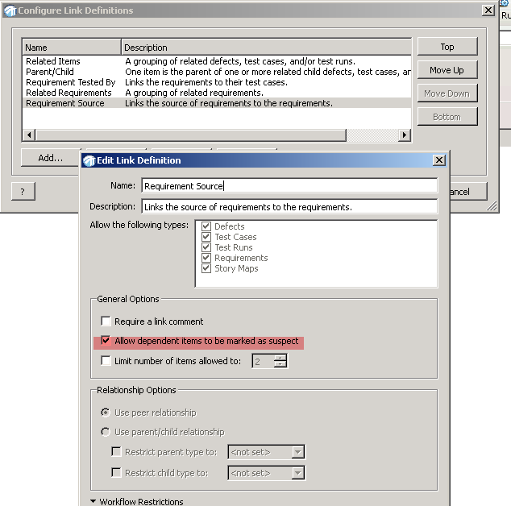

The Flag will not appear when you use the Mark Suspect function on the highest level requirement whether it has items attached to it or not since the function is intended for the lower level linked items. If you have a need to mark the high level requirements as needing attention you could create a new workflow event that changes the status of your requirement. As you can see in the next screen shot when the user has the requirement open he can see that the workflow event has been performed but when he looks in the Requirement Document this Requirement does not have a Flag indicating it is suspect. The customer could create a new workflow event that would change the status to indicate a suspect requirement.

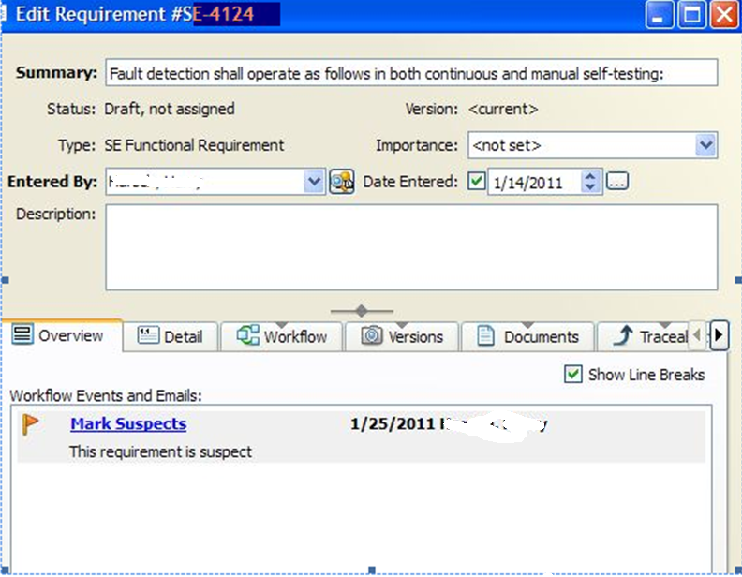
When a item attached to a Top\High Level Requirement is Marked Suspect the Requirement has a Flag showing between the Status and the version field as shown in this next screen shot
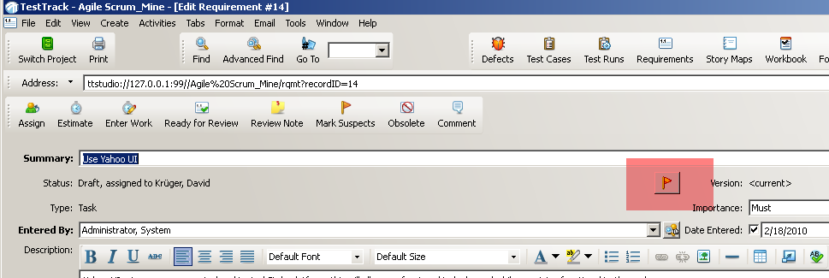

And when you review the Requirement document this requirement is associated with you will see the flag as shown below.

Additional Information:
In the following screen shots you can see that Requirement #41 has a Parent/Child and a Related Requirement link that is marked suspect. The
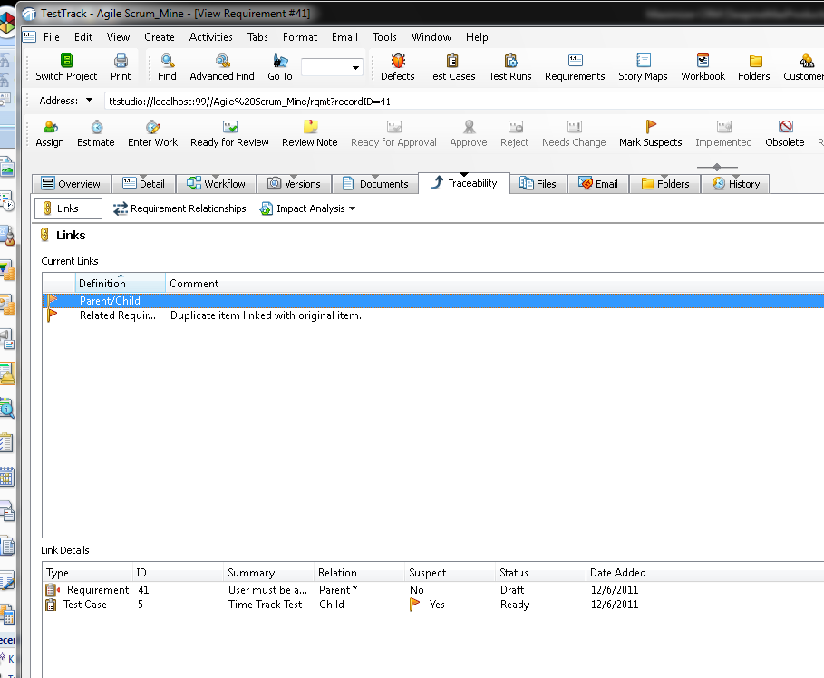
Parent Child Definition links to Test Case 5 and the Related Requirement Definition links to Requirement 2
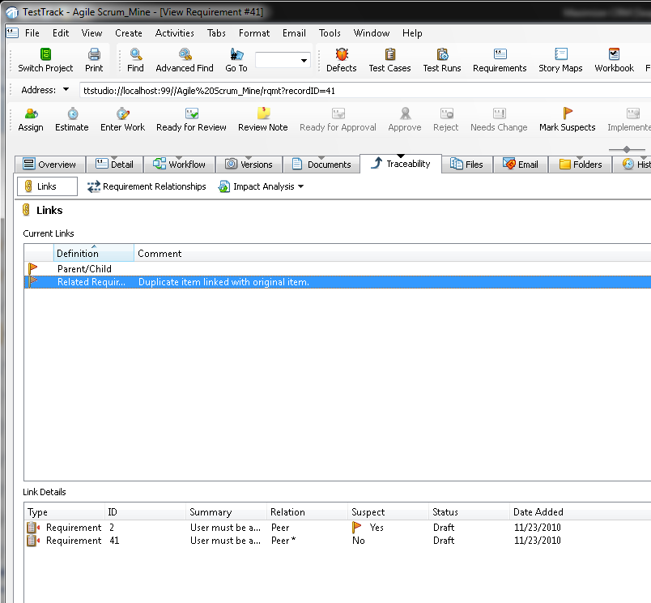

These items were marked suspect using the mark suspect workflow event with “Mark dependent items as suspect” checked
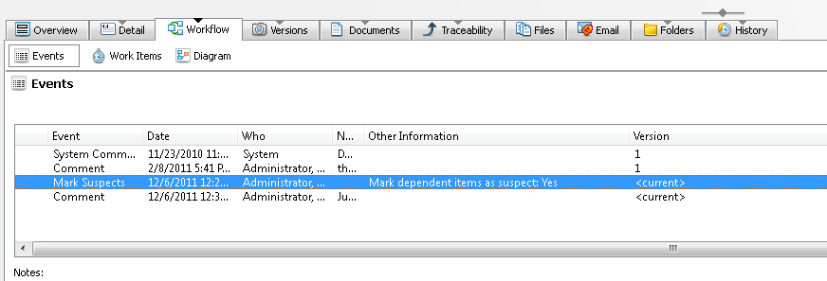

When I go back to the main requirement list window I see that Requirement 41 shows No in the “Is Marked As Suspect” column and that
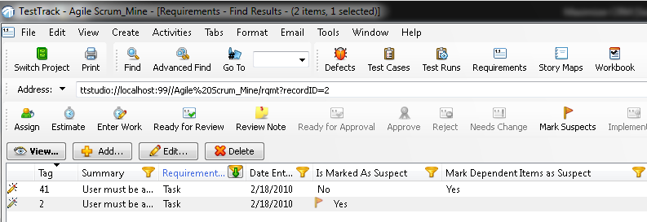
Requirement 2 show Yes in this column. If I go to the Main Test Case List Window I see that Test Case 5 show Yes in the “Is Marked As
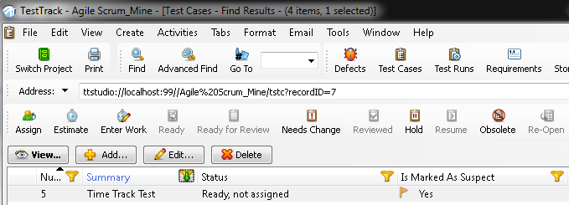
Suspect” column. This is correct behavior since it is Test Case 5 and Requirement 2 that are suspect. If I clear suspect on either item the “Is Marked As Suspect” column for that item will change to No and the Flag will be removed.

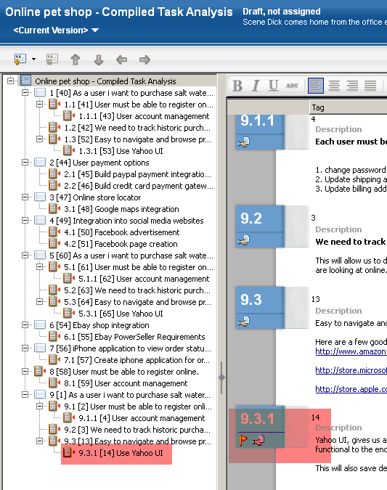

You can also easily see any requirement that have items linked to them by adding the “Is Marked As Suspect” Column to the Main Requirements List Window.
